WORLD PIANO TEACHERS ASSOCIATION WPTA ARGENTINA
INTERNATIONAL PIANO COMPETITION IPC 2022
Edición ONLINE

Application Form Only Category:

ARGENTINA AWARD for CURRENT PIANISTIC CREATION

Name:

Last Name:

Gender:

Nationality:

Date of birth (day / month / year):

Country of birth:

Address (where currently residing):

Mobile phone:

Email:

1) For the audition provide

Online links of your video presentation:

Works performed:

Date of performance:

Place:

2) The listening program sent as an online video link, will be as detailed in points number 9, 10, 11, 12 and 13, on the file Rules Category Performance of the competition.

3) When applying to the WPTA Argentina IPC 2022 piano performance category, a single payment of 50 euros will be made, which includes the new ARGENTINA AWARD category for the CURRENT PIANISTIC CREATION, please consult the application procedure for the Performers category (form 03). To apply in both categories please download both forms (03-05) to be completed and sent to the mail:
wpta.argentina@gmail.com
Those who wish can only apply in the new category, in which case they will send the chosen piece and a single form (05) for the ARGENTINE AWARD category to the CURRENT PIANISTIC CREATION with a payment of 25 euros.

Payment details of the application of your request when applying only in the new category:

Visit

https://www.paypal.com/cgi-bin/webscr?cmd=_s-xclick&hosted_button_id=6VK5YLN8RX8WA

Before completing the payment, you must agree to the number of applications registered in your shopping cart (1), as well as the total amount you are paying (€25).

Below is an application model:

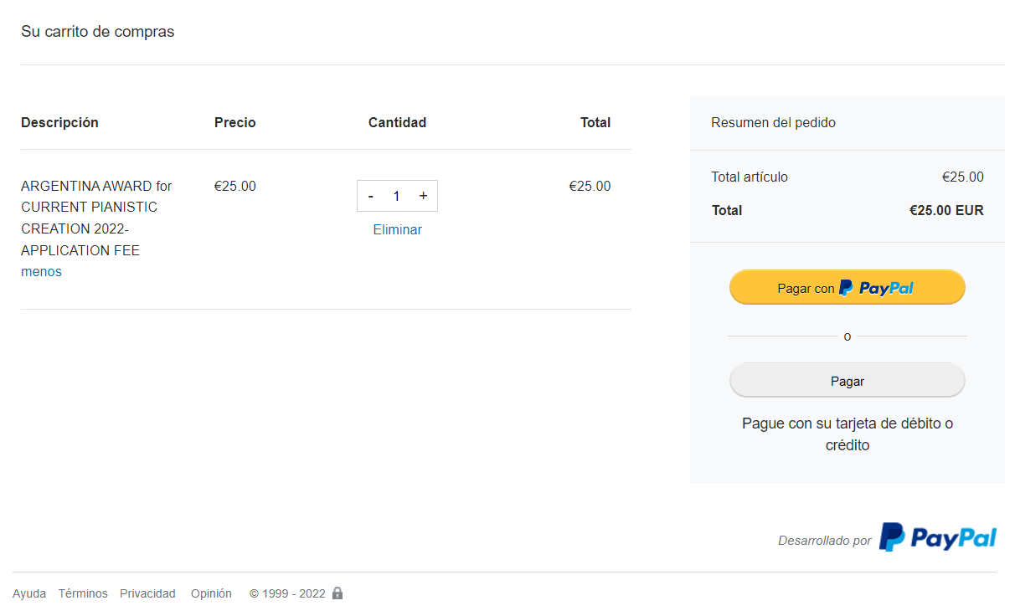

After successfully processing the corresponding registration payment, you will receive a confirmation email from Paypal.

Please send this confirmation email to wpta.argentina@gmail.com and be sure to keep the original email received as you will need it to complete the application form.

Follow the instructions to make the payment. After completing it, the payment receipt must be sent to the email: wpta.argentina@gmail.com

Also, provide this information:

Last four digits of credit or debit card used for payment: _ _ _

or write: "I used funds on Pay-Pal account for payment"

4. Other materials Send a photo (suitable for publications, greater than 1000 pixels) in colour and a brief biography/CV in english and spanish language to: wpta.argentina@gmail.com

5. The complete program (highlight in bold the pieces of the audition):

PIECE WORK - COMPOSER (include opus / number, tone, movement, etc.) – TIME

TOTAL DURATION___________

By typing my name below and submitting this Application Form to the ARGENTINA AWARD to the CURRENT PIANISTIC CREATION in the 2022 WPTA Argentina IPC Competition, I affirm that all the information contained here and in my biography is true. I agree with the WPTA Argentina IPC 2022 rules and accept the decisions of the competition jury as final.Nombre y apellido:

First and last name:

Date:

Number and type of document:

Signature:

